**Abstract Factory Design Pattern**

Define an abstract class creating families of related object but without specifying their concrete sub class

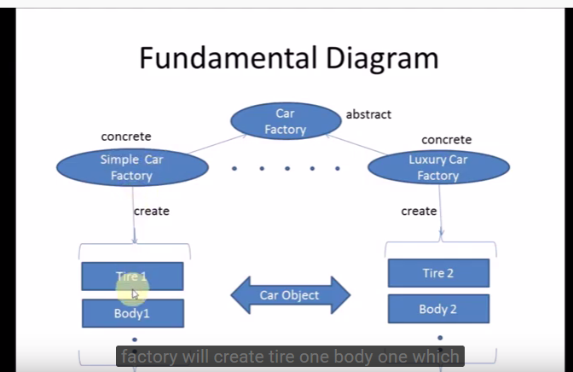

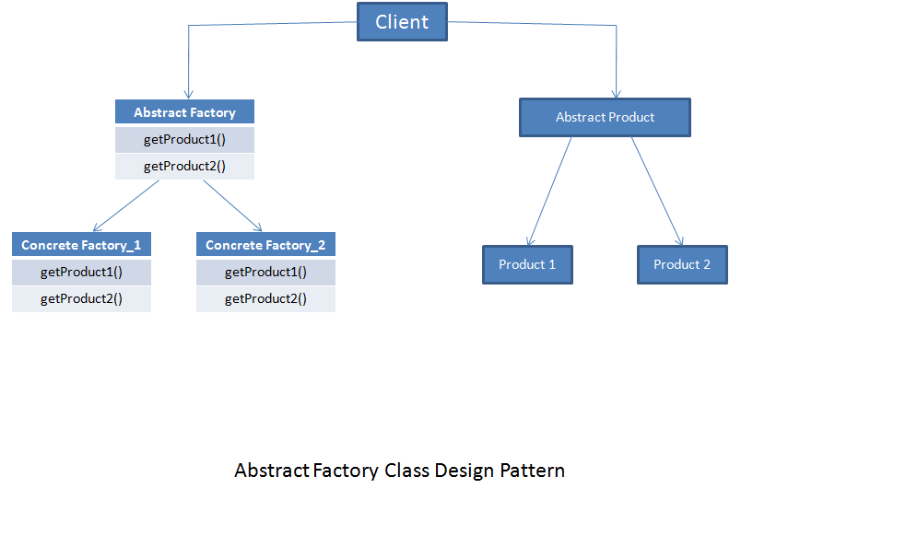

**Builder Design Pattern** – Creating Object with composing complex object and director will handle that

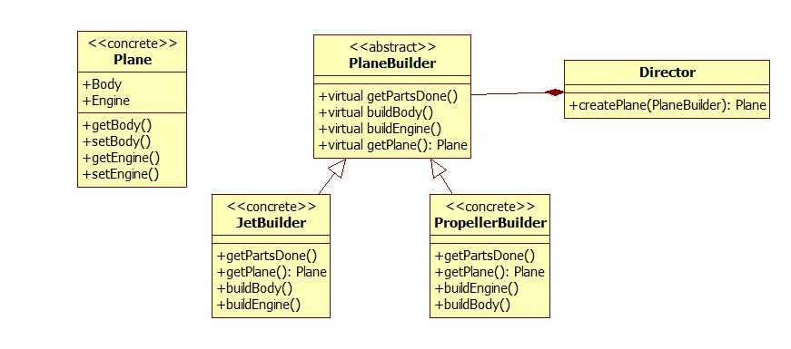

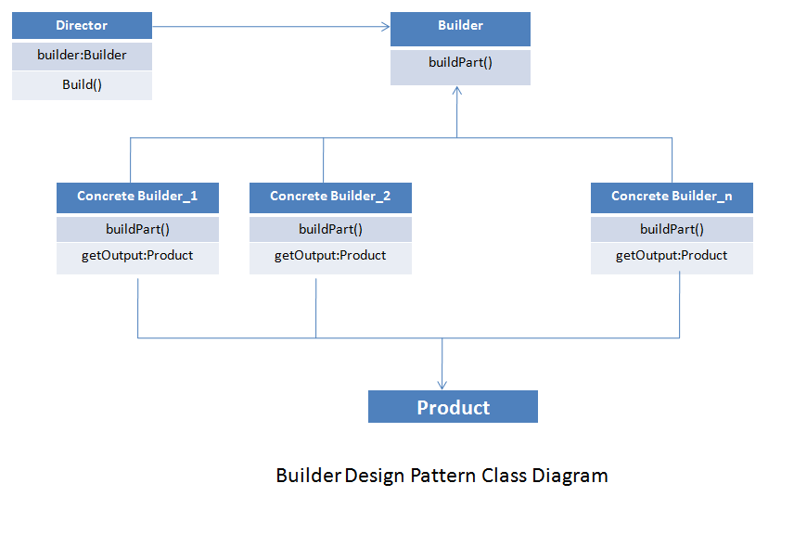

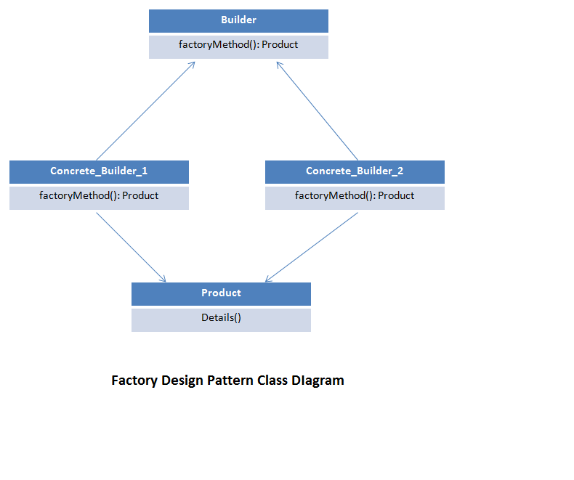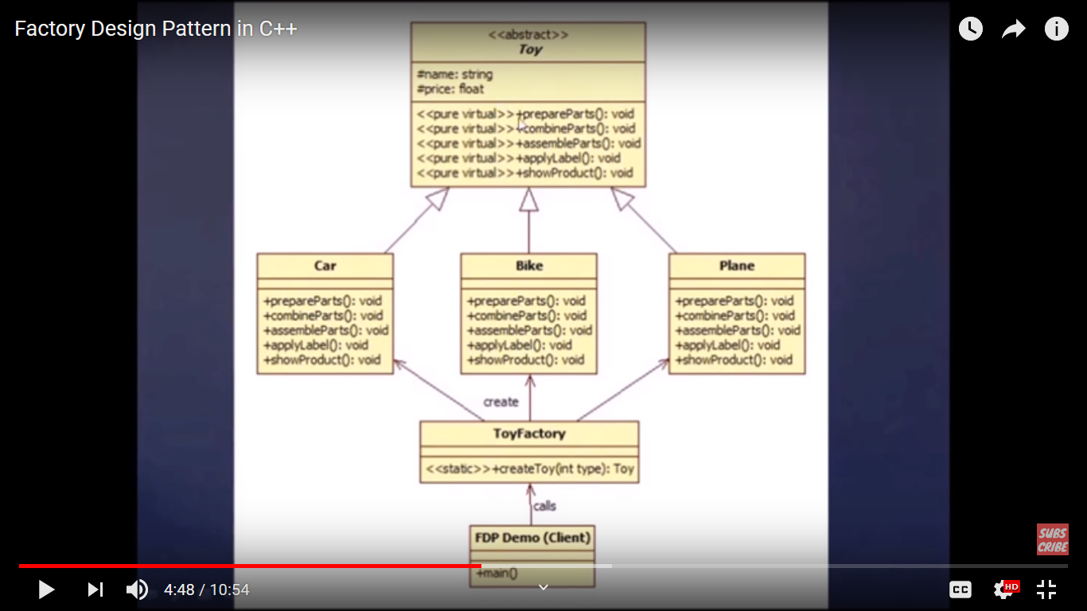

**Factory Design Pattern:**

It create object intialized object , It kind of virtual constructor

**Singleton Design Pattern**

It will create only one instance of object

- Private Constructor

- Static Member variable

- static member function

**Object Pool**

Object pooling can offer a significant performance boost; it is most effective in situations where the cost of initializing a class instance is high, the rate of instantiation of a class is high, and the number of instantiations in use at any one time is low.

class ObjectPool

{

private:

std::list<Resource*> resources;

static ObjectPool* instance;

ObjectPool() {}

public:

/**

* Static method for accessing class instance.

* Part of Singleton design pattern.

*

* @return ObjectPool instance.

*/

static ObjectPool* getInstance()

{

if (instance == 0)

{

instance = new ObjectPool;

}

return instance;

}

/**

* Returns instance of Resource.

*

* New resource will be created if all the resources

* were used at the time of the request.

*

* @return Resource instance.

*/

Resource* getResource()

{

if (resources.empty())

{

std::cout << "Creating new." << std::endl;

return new Resource;

}

else

{

std::cout << "Reusing existing." << std::endl;

Resource* resource = resources.front();

resources.pop_front();

return resource;

}

}

/**

* Return resource back to the pool.

*

* The resource must be initialized back to

* the default settings before someone else

* attempts to use it.

*

* @param object Resource instance.

* @return void

*/

void returnResource(Resource* object)

{

object->reset();

resources.push_back(object);

}

};

ObjectPool* ObjectPool::instance = 0;

int main()

{

ObjectPool* pool = ObjectPool::getInstance();

Resource* one;

Resource* two;

/* Resources will be created. */

one = pool->getResource();

one->setValue(10);

std::cout << "one = " << one->getValue() << " [" << one << "]" << std::endl;

two = pool->getResource();

two->setValue(20);

std::cout << "two = " << two->getValue() << " [" << two << "]" << std::endl;

pool->returnResource(one);

pool->returnResource(two);

/* Resources will be reused.

* Notice that the value of both resources were reset back to zero.

*/

one = pool->getResource();

std::cout << "one = " << one->getValue() << " [" << one << "]" << std::endl;

two = pool->getResource();

std::cout << "two = " << two->getValue() << " [" << two << "]" << std::endl;

return 0;

}

**Prototype Design Pattern**

Creating Object is expensive operation as compare to copying the object

return always cloned object

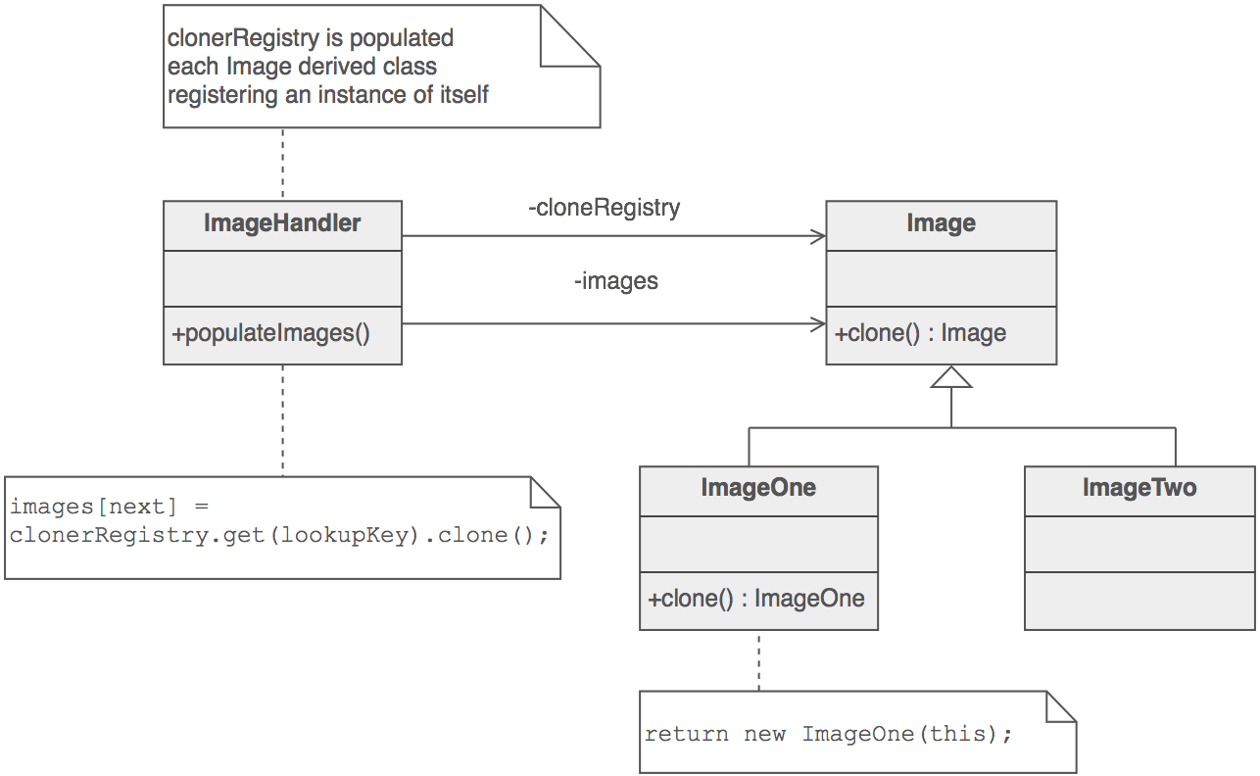

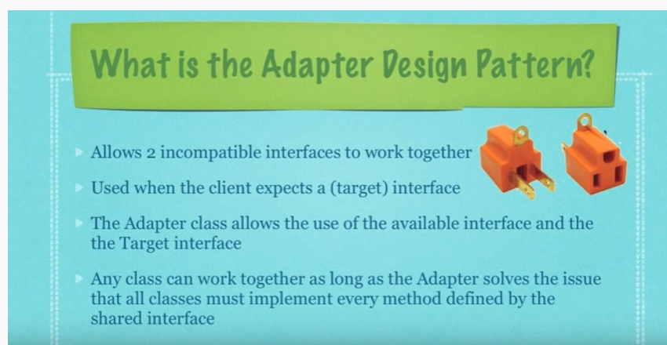

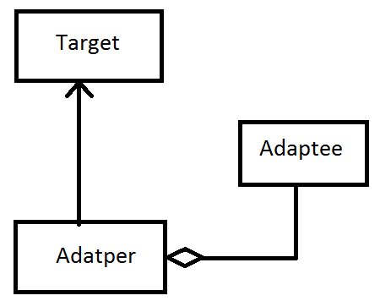

**adapterPattern.txt**

**Bridge Pattern (Structural Pattern)**

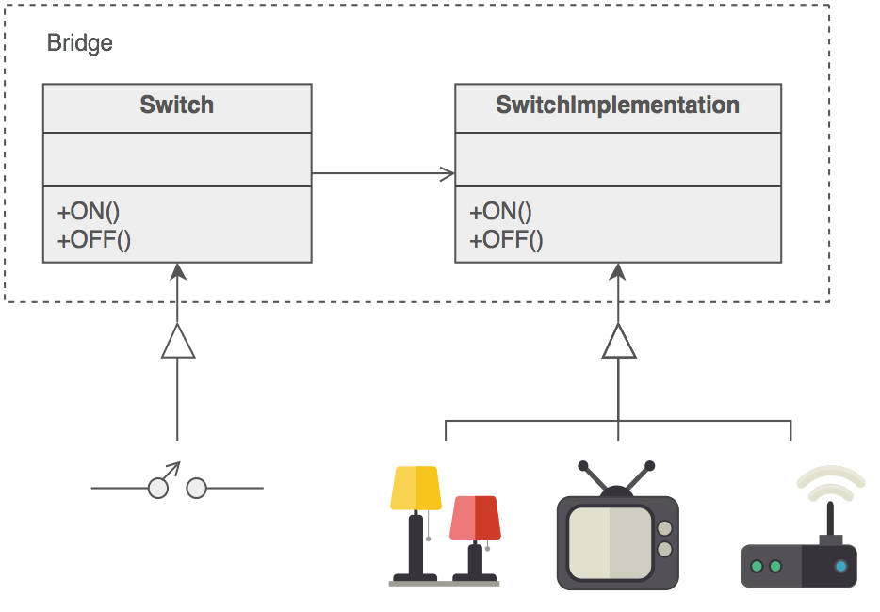

**Startegy Pattern (Behavioral Pattern )**

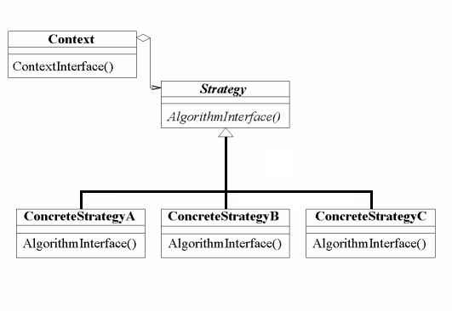

**Template Design Patter (Behavioral Pattern)**

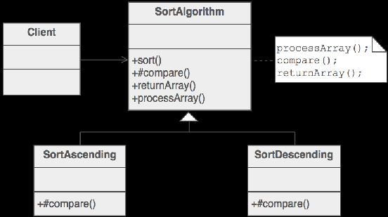

**Decorator Pattern (Structural Pattern)**

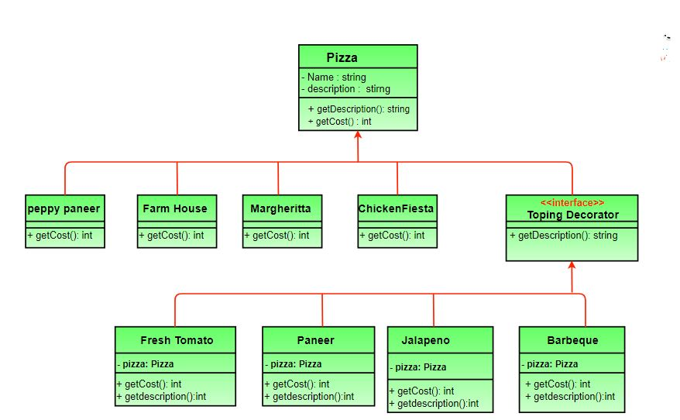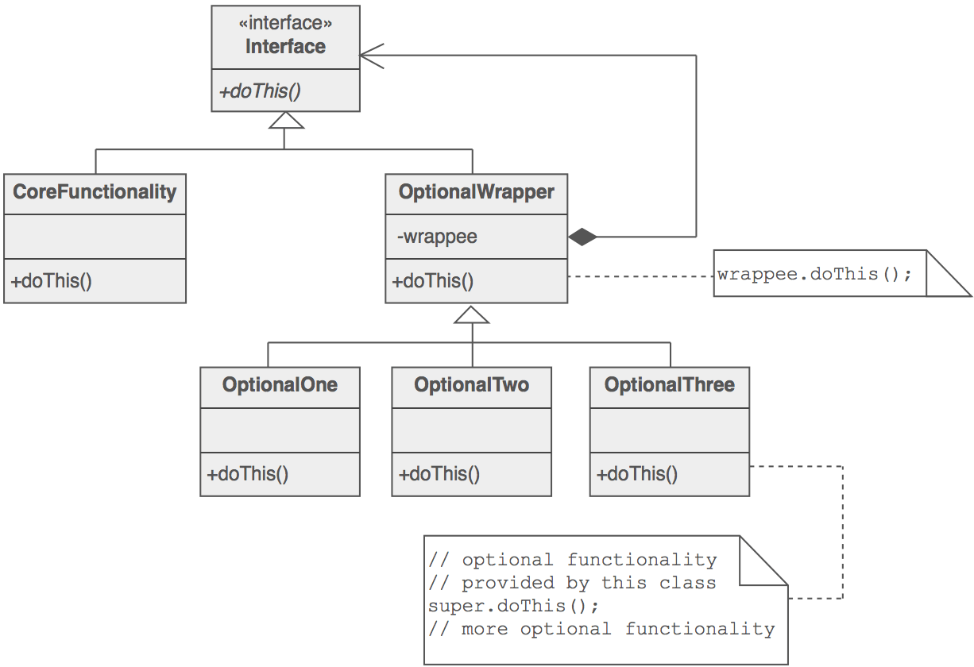

**Composite Pattern (SP)**

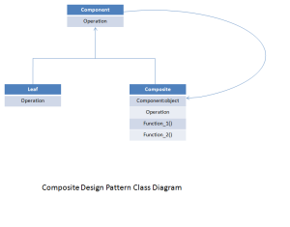

**Fly Weight Pattern (SP)**

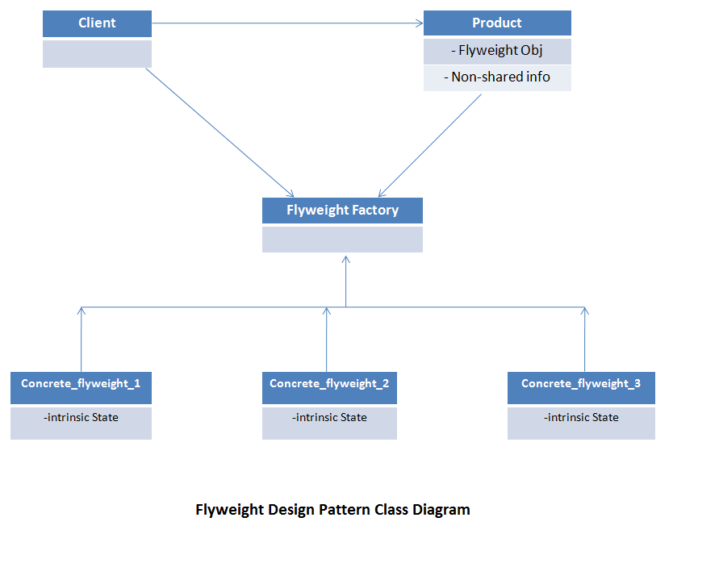**Facade Pattern (SP)**

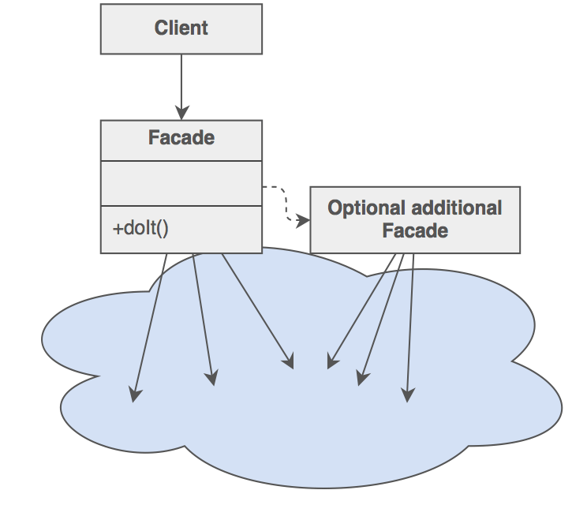

**Proxy Pattern (SP)**

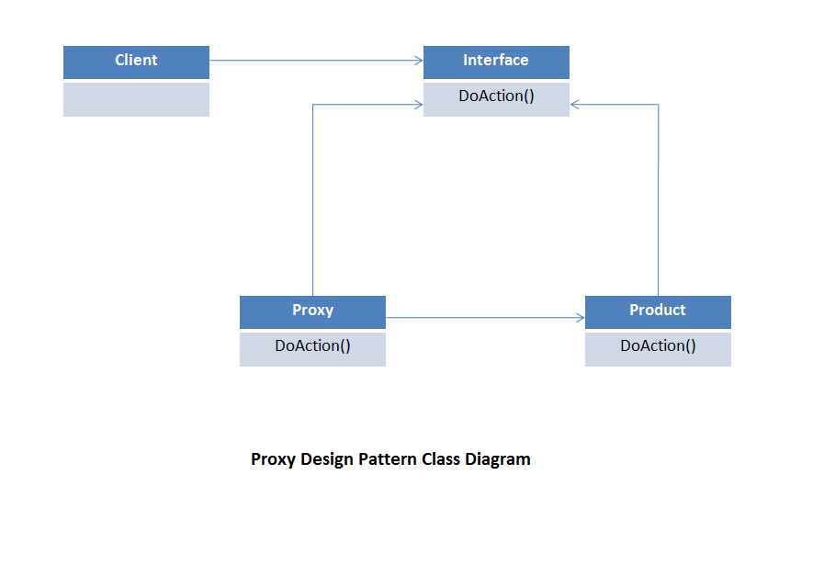

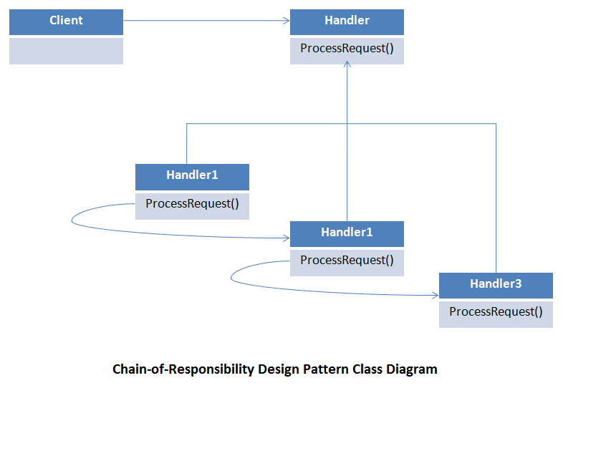**Chain of Responsibility**